**Music Rights Management And Royalty Distribution**

**With Blockchain**

**Abstract**

Imagine a world where musicians have more control over their music and get paid fairly for their work. That’s exactly what our research aims to achieve by using cutting -edge blockchain and smart contract technology. BMCProtector, an Ethereum-based app designed to give musicians the power to manage and protect their copyrights easily.

With BMCProtector, they can keep track of their music rights on a transparent public ledger, with no middlemen involved. By using blockchain, we're bypassing the need for intermediaries, so musicians get paid faster and more accurately. It's all about making sure everyone gets their fair share of the earnings. To tackle piracy head-on , we’re using advanced encryption and watermarking techniques.

**Keywords :**

Blockchain, Music Distribution, Copyright Protection, Smart Contract , BMCProtector

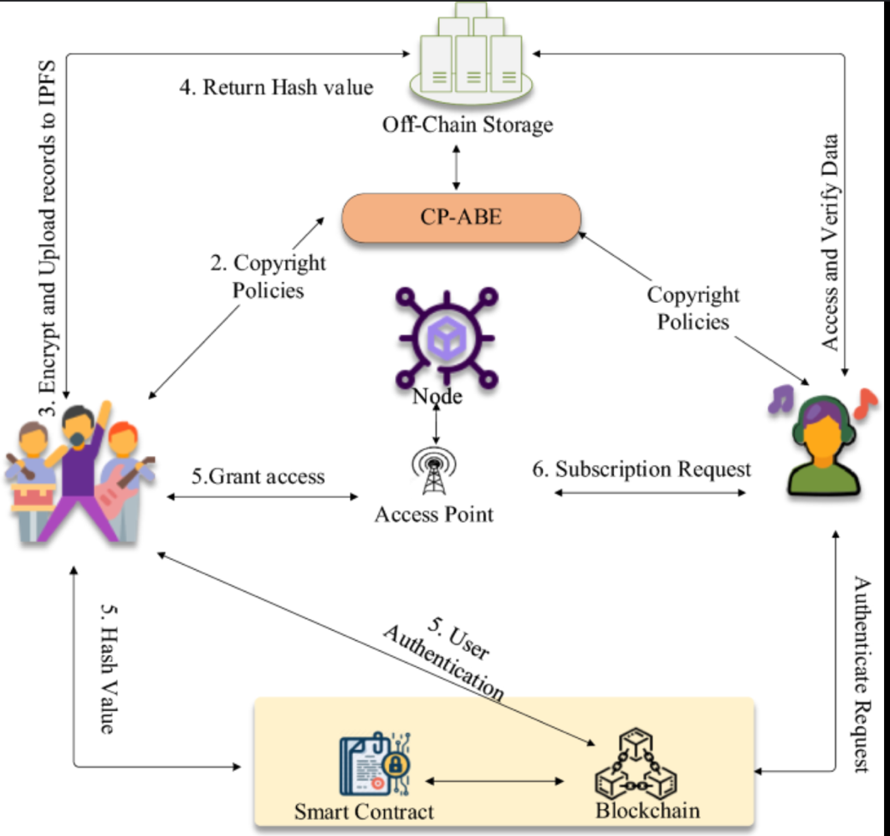

Introduction

A music distribution model that uses blockchain technology to protect music copyrights and rights holders' rights [1] can be used to solve the challenges faced right now. The model uses a blockchain to store and distribute music assets, and it uses smart contracts to manage copyright distribution and royalty payments [3, 4,6]. The model can provide integrity, confidentiality, and non-repudiation of assets, and that it can minimize the problem of single points of failure (SPOF) [1].

It allows musicians to easily approve and manage their music copyright, and that it can allow rights holders to receive royalties automatically and immediately, even if no broker is involved in the distribution process [1]. The challenges associated with using blockchain technology in the music industry, is the scalability of the technology [7]. However, the benefits of using blockchain technology outweigh the challenges, and that it has the potential to revolutionize the music industry [1].

A music management system that includes modules for generating, transmitting, settling, and analysing music data is needed [11, 12, 13, 14]. The blockchain-based music distribution framework, includes nodes for registering music assets, managing music copyright distribution, and creating and verifying music assets [3, 4, 6]. We also discuss the requirements for the framework, the structure of block transactions, and the operation flow of the system [11, 12, 13].

Blockchain offers both transparency and security for music rights management. Its clear and tamper-proof record keeps everyone informed, while its decentralized nature safeguards music assets and rights data. It provides copyright protection for music by securely storing ownership details, tracking usage rights, and simplifying ownership verification. This provides a robust shield for creators. It’s also cost efficient by eliminating the need for manual processes and intermediaries, reducing administrative overhead and leading to significant cost savings for artists and rights holders.

Decentralization of the distribution process removes the need for centralized authorities or control by a single entity which empowers the music industry. Its immutable record keeping ensures that once data is recorded, it cannot be altered or deleted. It automates royalty payments through smart contracts, eliminating delays, discrepancies, and potential leakage. This ensures artists and rights holders receive their rightful share of revenue, fostering a more equitable and transparent ecosystem.

Lastly , blockchain opens doors to a global music market and facilitates easy access to music rights information and royalty payments worldwide. It empowers artists and rights holders to reach a broader audience and receive their rewards , irrespective of their origin.

Finally, we can conclude by discussing the potential benefits of the model and by outlining some areas for future research [15, 16, 17, 18]. We believe that this model can help to create a more transparent and efficient music industry, and that it can benefit both musicians and rights holders.

**References**

[1] Davide Sciaky. 2019.The digital transformation of the music industry through applications of blockchain technology, Degree Project in Media Technology, Second Cycle, 30 Credits Stockholm, Sweden, 2019.

[2] Quantone Music. 2016. The Problems with Music Streaming [online] Available at: http://quantonemusic.com/2016/04/26/theproblemswith-music-streaming/, (2016).

[3] O'Dair, M., Beaven, Z., Neilson, D., Osborne, R., & Pacifico, P. 2016. Music on the Blockchain.

[4] Music Ally. 2016. Blockchain: Music Without the Middlemen?

[5] O’Dair, M. and Beaven, Z. 2017. The networked record industry: How blockchain technology could transform the record industry. Strategic Change, 26(5), 471-480.

[6] Fabian, E. 2017. Blockchain, Digital Music and Lex Mercatoria. US-China L. Rev., 14, 852.

[7] BitRewards. 2018. Blockchain Scalability: The Issues, and Proposed Solutions [online] Available at: <https://medium.com/@bitrewards/blockchain-scalabilitythe-issuesand-proposed-solutions-2ec2c7ac98f0>

[8] Yu-Ching Lin, Yi-Hsuan Yang and Homer H. Chen, “Exploiting Online Music Tags for Music Emotion Classification,” TOMM, October. 2011. <http://dx.doi.org/10.1145/2037676.2037683>

[9] P. Knees, E. Pampalk, and G. Widmer, “Artist Classification with Webbased Data,” in Proceedings of the International Symposium on Music Information Retrieval (ISMIR), Barcelona, Spain, 2004.

[10] M. Schedl, “#nowplaying Madonna: A Large-Scale Evaluation on Estimating Similarities between Music Artists and Between Movies from Microblogs. Information Retrieval,” vol. 15, pp. 183–217, June 2012.

[11] N. Koenigstein, G. Dror, and Y. Koren, “Yahoo! Music recommendations: modeling music ratings with temporal dynamics and item taxonomy,” in Proc. ACM RecSys, pp. 165–1722011.

[12] R. Cai, C. Zhang et al. 2007. “Musicsense: contextual music recommendation using emotional allocation modeling,” in Proc. ACM MM, pp. 553–556

[13] M. Casey, R. Veltkamp, M. Goto, M. Leman, C. Rhodes, and M. Slaney, “Content-based music information retrieval: Current directions and future challenges,” IEEE, vol. 96, no. 4, pp. 668 –696, 2008.

[14] K. R. Byun and M. Y. Kim, “Music Genre/Mood Classification for Music Recommendation,” THE Institute of Electronics Engineers of Korea, July. 2013.

[15] Zheng, Z., Xie, S., Dai, H. N., & Wang, H. 2016. Blockchain challenges and opportunities: A survey. Work Pap.–2016.

[16] M. Levy and M. Sandler, “A semantic space for music derived from social tags,” in Proceedings of the International Conference on Music Information Retrieval (ISMIR), Vienna, Austria, 2007.

[17] P. Lamere, “Social Tagging and Music Information Retrieval”, Journal of New Music Research: Special Issue: From Genres to Tags – Music Information Retrieval in the Age of Social Tagging, vol. 37, no. 2, pp. 101–114, 2008.

[18] R. Mayer, R. Neumayer, and A. Rauber, “Rhyme and Style Features for Musical Genre Classification by Song Lyrics,” in Proceedings of the International Conference on Music Information Retrieval (ISMIR), Philadelphia, PA, USA, 2008.

[19] <https://dl.acm.org/doi/10.1145/3301403.3301404>

**Literature Review**

**Music Industry Challenges**

The music industry has faced significant challenges in recent decades, particularly with the rise of piracy and declining sales in the late 1990s and early 2000s. Despite the emergence of streaming services like Spotify, which accounts for 38% of recorded music profits, many artists have expressed dissatisfaction with the way streaming platforms pay artists, claiming that the current model is unsustainable, especially for younger or smaller artists who do not have millions of streams. [1]

**Music Licensing Issues**

Another issue identified in the music industry is the fragmentation of music licensing. Song ownership is often divided among various groups, and there is no comprehensive database of song ownership metadata. Consequently, paying the owners of a song requires searching across multiple proprietary databases, leading to delayed payments and, in some cases, royalties that never reach their rightful owners due to inaccurate licensing data, a problem known as the "black box." [1] [3]

**Blockchain Technology Overview**

Blockchain technology, which originated as the underlying technology for the cryptocurrency Bitcoin, has the potential to address some of these challenges in the music industry. Blockchain is a distributed, tamper-proof ledger that records transactions without the need for a central authority. [5] Its advantages include secure and immutable record-keeping, the ability to automate processes through smart contracts, and the potential to eliminate intermediaries and their associated fees. [5] [6]

**Blockchain Scalability Limitation**

However, one potential limitation of blockchain technology is scalability. As the number of transactions increases, the size of the blockchain grows, and the time required to process transactions also increases. Currently, the Bitcoin blockchain can handle around 60 transactions per second, while Visa's peak rate is 47,000 transactions per second. This limitation needs to be addressed for blockchain technology to become competitive with other alternatives. [7]

**Blockchain Applications in Music Industry**

In the context of the music industry, researchers have proposed three main applications of blockchain technology: (1) creating a networked database of copyright ownership to address music licensing issues, (2) using smart contracts to manage royalty payments and facilitate micropayments, and (3) improving transparency within the value chain by providing a clear record of transactions and royalty distribution. [9] [10] [11] [12] [13]

**Music Management System**

The authors also describe a music management system consisting of four modules: music generation, music transmission, music settlement, and distribution analysis. The music classification algorithms assign categories to similar music by generating music vectors from tags and using machine learning algorithms like Complement Naive Bayes and J48 decision trees for training and classification. [14] [15] [16] [17]

**Blockchain-based Music Distribution Framework**

To incorporate blockchain technology into the music management system, the authors propose a blockchain-based music distribution framework. This framework involves participating nodes for registering music assets, managing copyright distribution, and enabling general users to create and verify music assets. The framework aims to provide integrity, confidentiality, and non-repudiation through cryptographic techniques like hashing, encryption, digital signatures, and signature verification. [18] [19] [20] [21] [22] [23] [24] [25]

**BMC Protector Integration**

The proposed blockchain-based music distribution framework can be integrated with BMC Protector, a software solution designed to protect data and applications from unauthorized access, misuse, and cyber threats. By incorporating BMC Protector into the framework, an additional layer of security can be provided to the music assets and associated metadata stored on the blockchain network. BMC Protector's data encryption, access control, and auditing capabilities can help ensure the confidentiality, integrity, and availability of the music data, while also enabling compliance with relevant data protection regulations. [26] [27] [28] [29] [30] [31]

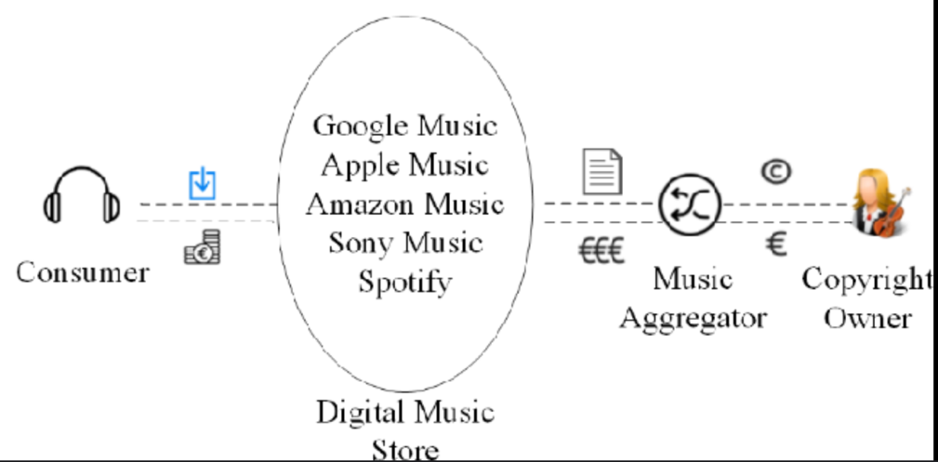

**Related Works**

Several companies and researchers have explored the application of blockchain technology in the music industry. Some notable examples include Musicoin, Ujo Music, and Dot Blockchain Music, which aim to facilitate direct payments to artists, streamline licensing processes, and improve transparency in royalty distribution. Additionally, organizations like the Open Music Initiative and the Blockchain Music Initiative are collaborating to develop industry-wide standards and best practices for leveraging blockchain technology in the music ecosystem.

**References**

[1] Davide Sciaky. 2019.The digital transformation of the music industry through applications of blockchain technology, Degree Project in Media Technology, Second Cycle, 30 Credits Stockholm, Sweden, 2019.

[2] IFPI, I. 2018. IFPI Global Music Report 2018 [online] Available at: <https://www.ifpi.org/downloads/GMR2018.pdf>

[3] Quantone Music. 2016. The Problems with Music Streaming [online] Available at: http://quantonemusic.com/2016/04/26/theproblemswith-music-streaming/, (2016).

[4] Resnikoff, P. 2018. Paradise Distribution Estimates That 97% of ‘Black Box’ Royalties Can Be Resolved & Paid [online] Available at: [https://www.digitalmusicnews.com/2018/10/09/paradis e-distributionblack-box/](https://www.digitalmusicnews.com/2018/10/09/paradis%20e-distributionblack-box/)

[5] BlockchainHub. 2017. Blockchain Explained - Intro - Beginners Guide to Blockchain [online] Available at: <https://blockchainhub.net/blockchain-intro/>

[6] Peters G.W., Panayi E. 2016. Understanding Modern Banking Ledgers Through Blockchain Technologies: Future of Transaction Processing and Smart Contracts on the Internet of Money. In: Tasca P., Aste T., Pelizzon L., Perony N. (eds) Banking Beyond Banks and Money. New Economic Windows. Springer, Cham

[7] BitRewards. 2018. Blockchain Scalability: The Issues, and Proposed Solutions [online] Available at: <https://medium.com/@bitrewards/blockchain-scalabilitythe-issuesand-proposed-solutions-2ec2c7ac98f0>

[8] Zheng, Z., Xie, S., Dai, H. N., & Wang, H. 2016. Blockchain challenges and opportunities: A survey. Work Pap.–2016.

[9] Fabian, E. 2017. Blockchain, Digital Music and Lex Mercatoria. US-China L. Rev., 14, 852.

[10] O'Dair, M., Beaven, Z., Neilson, D., Osborne, R., & Pacifico, P. 2016. Music on the Blockchain.

[11] Music Ally. 2016. Blockchain: Music Without the Middlemen?

[12] O’Dair, M. and Beaven, Z. 2017. The networked record industry: How blockchain technology could transform the record industry. Strategic Change, 26(5), 471-480.

[13] Sitonio, C. and Nucciarelli, A. 2018. The Impact of Blockchain on the Music Industry.

[14] N. Koenigstein, G. Dror, and Y. Koren, “Yahoo! Music recommendations: modeling music ratings with temporal dynamics and item taxonomy,” in Proc. ACM RecSys, pp. 165–1722011.

[15] R. Cai, C. Zhang et al. 2007. “Musicsense: contextual music recommendation using emotional allocation modeling,” in Proc. ACM MM, pp. 553–556

[16] M. Casey, R. Veltkamp, M. Goto, M. Leman, C. Rhodes, and M. Slaney, “Content-based music information retrieval: Current directions and future challenges,” IEEE, vol. 96, no. 4, pp. 668 –696, 2008.

[17] K. R. Byun and M. Y. Kim, “Music Genre/Mood Classification for Music Recommendation,” THE Institute of Electronics Engineers of Korea, July. 2013.

[18] Yu-Ching Lin, Yi-Hsuan Yang and Homer H. Chen, “Exploiting Online Music Tags for Music Emotion Classification,” TOMM, October. 2011. <http://dx.doi.org/10.1145/2037676.2037683>

[19] P. Knees, E. Pampalk, and G. Widmer, “Artist Classification with Webbased Data,” in Proceedings of the International Symposium on Music Information Retrieval (ISMIR), Barcelona, Spain, 2004.

[20] M. Schedl, “#nowplaying Madonna: A Large-Scale Evaluation on Estimating Similarities between Music Artists and Between Movies from Microblogs. Information Retrieval,” vol. 15, pp. 183–217, June 2012.

[21] M. Levy and M. Sandler, “A semantic space for music derived from social tags,” in Proceedings of the International Conference on Music Information Retrieval (ISMIR), Vienna, Austria, 2007.

[22] P. Lamere, “Social Tagging and Music Information Retrieval”, Journal of New Music Research: Special Issue: From Genres to Tags – Music Information Retrieval in the Age of Social Tagging, vol. 37, no. 2, pp. 101–114, 2008.

[23] R. Mayer, R. Neumayer, and A. Rauber, “Rhyme and Style Features for Musical Genre Classification by Song Lyrics,” in Proceedings of the International Conference on Music Information Retrieval (ISMIR), Philadelphia, PA, USA, 2008.

[24] E. Law, L. von Ahn, R. Dannenberg, and M. Crawford, “Tagatune: A Game for Music and Sound Annotation,” in Proceedings of the International Conference on Music Information Retrieval (ISMIR), Vienna, Austria, 2007.

[25] M. Schedl, “Automatically Extracting, Analyzing, and Visualizing Information on Music Artists from the World Wide Web,” PhD thesis, Johannes Kepler University Linz, Austria, 2008.

[26] P. Knees and M. Schedl, “Towards Semantic Music Information Extraction from the Web Using Rule Patterns and Supervised Learning,” in Proceedings of the Workshop on Music Recommendation and Discovery (WOMRAD), Chicago, IL, USA, 2011.

[27] P. Knees, E. Pampalk, and G. Widmer, “Artist Classification with Webbased Data,” in Proceedings of the International Symposium on Music Information Retrieval (ISMIR), Barcelona, Spain, 2004.

[28] B. Whitman and S. Lawrence, “Inferring Descriptions and Similarity for Music from Community Metadata”. in Proceedings of the International Computer Music Conference (ICMC), G¨oteborg, Sweden, 2002.

[29] P. Knees, T. Pohle, M. Schedl, and G. Widmer, “A Music Search Engine Built upon Audio-based and Web-based Similarity Measures,” in Proceedings of the ACM SIGIR, Amsterdam, Netherlands, 2007.

[30] L. Barrington, D. Turnbull, M. Yazdani, and G. Lanckriet, “Combining audio content and social context for semantic music discovery,” in Proceedings of the ACM SIGIR, Boston, MA, USA, 2009.

[31] N. Hariri, B. Mobasher, and R. Burke, “Context-aware music recommendation based on latenttopic sequential patterns,” in Proc. ACM RecSys, pp. 131–138, 2012.

**COMPARATIVE ANALYSIS**

The comparative analysis presents several blockchain-based approaches for addressing challenges in the music industry, such as lack of transparency, delayed royalty payments, and copyright infringement. The solutions leverage blockchain technology, smart contracts, distributed file systems (IPFS), and in some cases, deep learning techniques for content analysis and protection. Key advantages include enhanced transparency, secure and tamper-proof record-keeping, automated and direct royalty distribution to rights holders without intermediaries, simplified copyright management, and robust protection mechanisms like encryption and digital watermarking.

The proposed frameworks aim to streamline music distribution, establish unambiguous ownership, and facilitate fair compensation for artists and creators. However, challenges such as integration with existing systems, regulatory frameworks, scalability, user adoption, and addressing technical complexities need to be addressed for widespread implementation. The future scope includes expanding these solutions to other digital content domains like films, books, and broadcast media, leveraging their potential for comprehensive copyright management and equitable revenue distribution across creative industries.

The use of blockchain technology in the field of digital music

|  |  |  |  |  |  |  |
| --- | --- | --- | --- | --- | --- | --- |
| References | Domain | Work | How was it achieved | Advantages | Future scope | Disadvantages |
| The use of blockchain technology in the field of digital music | Digital Music Industry | Utilizing blockchain technology for copyright management, licensing, and royalty distribution in the digital music domain. | Blockchain provides a decentralized, immutable ledger for recording transactions and ownership information.  Smart contracts automate licensing agreements and royalty payments without intermediaries.  Digital watermarking and fingerprinting techniques track content distribution and identify unauthorized use. | Transparency and traceability of music ownership and distribution.  Automated, secure royalty payments directly to artists/rights holders.  Reduced transaction costs by eliminating intermediaries.  Tamper-proof records of transactions and ownership. | Integration with streaming platforms and digital music stores.  Expansion to other forms of digital content like films, books, etc.  Development of user-friendly interfaces and tools for artists and consumers.  Addressing scalability and performance challenges as adoption increases. | Legal and regulatory framework needs to catch up with blockchain technology.  Technical challenges in implementing and scaling blockchain solutions.  Potential resistance from existing intermediaries and stakeholders.  User adoption and education required for widespread acceptance. |

Copyright and privacy protection for digital music with the implementation of distributed ledger technology and deep

Learning

|  |  |  |  |  |  |  |
| --- | --- | --- | --- | --- | --- | --- |
| References | Domain | Work | How was it achieved | Advantages | Future scope | Disadvantages |
| Copyright and privacy protection for digital music with the implementation of distributed ledger technology and deep learning | Digital Music Copyright and Protection | Proposing the Digital Music Copyright and Protection (DMCP) model to analyze and manage digital music copyright and protection using Distributed Ledger Technology (DLT) and Deep Neural Networks (DNNs). | DLT used for copyright registration, tracking distribution, and automated royalty payments through smart contracts.  DNNs employed for automated music composition, classification, and analysis.  Encryption, watermarking, and fingerprinting techniques integrated for content protection. | Transparent and secure copyright registration and management using DLT.  Automated and efficient music composition and analysis through DNNs.  Robust protection mechanisms like encryption and watermarking.  Direct royalty payments to artists without intermediaries. | Integration with streaming platforms and digital music stores.  Expansion to other forms of digital content like films, books, etc.  Improving scalability and performance of DLT and DNN components.  Legal and regulatory framework updates for widespread adoption. | Technical challenges in implementing and scaling DLT and DNN solutions.  User adoption and education required for widespread acceptance.  Potential resistance from existing intermediaries and stakeholders. |

A Study on Blockchain-based Music Distribution

Framework: Focusing on Copyright Protection

|  |  |  |  |  |  |  |
| --- | --- | --- | --- | --- | --- | --- |
| References | Domain | Work | How was it achieved | Advantages | Future scope | Disadvantages |
| A Study on Blockchain-based Music Distribution Framework: Focusing on Copyright Protection | Music Industry | Implementing a blockchain-based music distribution framework for copyright protection. | By utilizing blockchain and smart contract technology to organize music assets into blocks, distribute them among blockchain nodes, ensure integrity, confidentiality, and non-repudiation of assets, and provide a transparent and secure platform for music transactions. | Enhanced transparency in music distribution.  Secure and tamper-proof record-keeping.  Direct and immediate royalty payments to rights holders.  Simplified management of music copyrights. | Expansion to other content industries, such as design, publishing, photography, film, and broadcasting. Potential for managing copyright of various content types through blockchain technology. | Potential scalability issues with blockchain technology.  Regulatory challenges and legal framework adaptation.  Initial setup and integration costs. |

|  |  |  |  |  |  |  |
| --- | --- | --- | --- | --- | --- | --- |
| References | Domain | Work | How was it Achieved | Advantages | Future Scope | Disadvantages/Challenges |
| Blockchain enabled Music Royalty Payment Scheme | Music Industry | Proposed a new royalty payment system based on blockchain technology to address issues like lack of transparency, delays in payments, and involvement of too many intermediaries in the traditional music royalty payment process. | The new model has 3 main actors - Collectors (who decide royalty amounts), Payers (who send funds to blockchain), and Receivers (artists who get paid through blockchain). Music metadata stored on IPFS, payment data on blockchain. Smart contracts distribute payments. | Improves transparency with immutable payment ledger, reduces delays by directly paying artists, accommodates all royalty types in one system, faster payments than traditional banking. | Not mentioned explicitly. | Integration with legacy systems/data can be challenging, lack of knowledge about blockchain among artists/users, business information may need to be omitted for privacy, blockchain still an emerging technology. |
|  |  |  |  |  | Prototype  demonstrated on local Ethereum blockchain to validate the concept. |  |

Blockchain enabled Music Royalty Payment Scheme

|  |
| --- |
|  |

Blockchain enabled NFT Application for Music Industry

|  |  |  |  |  |  |  |
| --- | --- | --- | --- | --- | --- | --- |
| References | Domain | Work | How was it Achieved | Advantages | Future Scope | Disadvantages/Challenges |
| Blockchain enabled NFT Application for Music Industry | Music Industry | Proposed a decentralized application based on NFTs and blockchain smart contracts to protect music copyrights, ownership, and enable fair royalty distribution. | Musicians upload songs to IPFS (decentralized file system), create NFT metadata with details like artist name, year, animation URL, image URL which is stored on blockchain smart contracts. Users can buy/sell/stream NFT music on platforms like OpenSea by connecting their wallets. Smart contracts handle automated royalty distribution among contributors. | Gives artists control over music rights without intermediaries, enables direct connection between artists and fans, transparent royalty distribution, establishes origin for music creators, tackles issues like revenue computation, income sharing delays, copyright and licensing problems in traditional music industry. | Not explicitly mentioned. | Integration challenges with existing systems/data, lack of blockchain knowledge among artists/users, business information privacy concerns, high resource requirements of blockchain, emerging technology so sustainability challenges for blockchain music startups to compete with major industry players. |
|  |  |  |  |  | Uses Web3.0 service Moralis for user authentication, wallet signature verification. |  |
|  |  |  |  |  | Deployed smart contracts on Ethereum Rinkeby Testnet for evaluating gas costs and efficiency. |  |

Digital Music Copyright Protection System Based on

Blockchain

|  |  |  |  |  |  |  |
| --- | --- | --- | --- | --- | --- | --- |
| References | Domain | Work | How was it Achieved | Advantages | Future Scope | Disadvantages/Challenges |
| Digital Music Copyright Protection System Based on Blockchain | Digital music copyright protection | Proposed a system combining Ethereum blockchain, digital signatures, IPFS, Shazam algorithm, and MySQL to achieve copyright registration, authentication, trading, and crowdfunding for digital music. | Smart contracts on Ethereum handle copyright registration, trading, crowdfunding. Digital signatures ensure transaction authenticity. Shazam extracts audio fingerprints which are stored on IPFS with hash on blockchain for originality checking. Frontend built with React, backend with Node.js/Express interacting with blockchain via Web3.js. | Compared to existing systems, more complete functions including crowdfunding. Digital signatures guarantee authenticity of crowdfunding. Ensures rights and interests of users. | Not explicitly mentioned. | Integration challenges with existing systems/data. |
|  |  |  |  |  | Stores only hash of audio fingerprint on blockchain to avoid storage limitations. |  |
|  |  |  |  |  | Uses public Ethereum blockchain accessible to all music creators and listeners. |  |

**CRITICAL THINKING**

It highlights the importance of blockchain technology and its potential applications in various industries, including the music industry. They emphasize the need for a solution to address issues related to music copyright protection and fair compensation for artists. More statistics on the specific challenges faced by the music industry, such as the impact of piracy and unfair revenue sharing practices could have been shown. The paper describes a music representation model and a music management system for organizing and classifying music content. This section could have been expanded to provide more details on how the music representation model integrates with the proposed blockchain framework.

The core of the proposed framework, including the requirements, block transaction structure, and operation flow is the Blockchain-based Music Distribution Framework. It outlines such as integrity, transparency, and security. Comparisons with existing blockchain-based music platforms (e.g., Musicoin, Blokur, etc.) would have been elevated the paper.

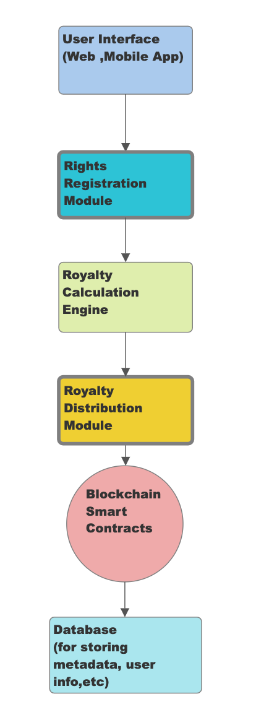 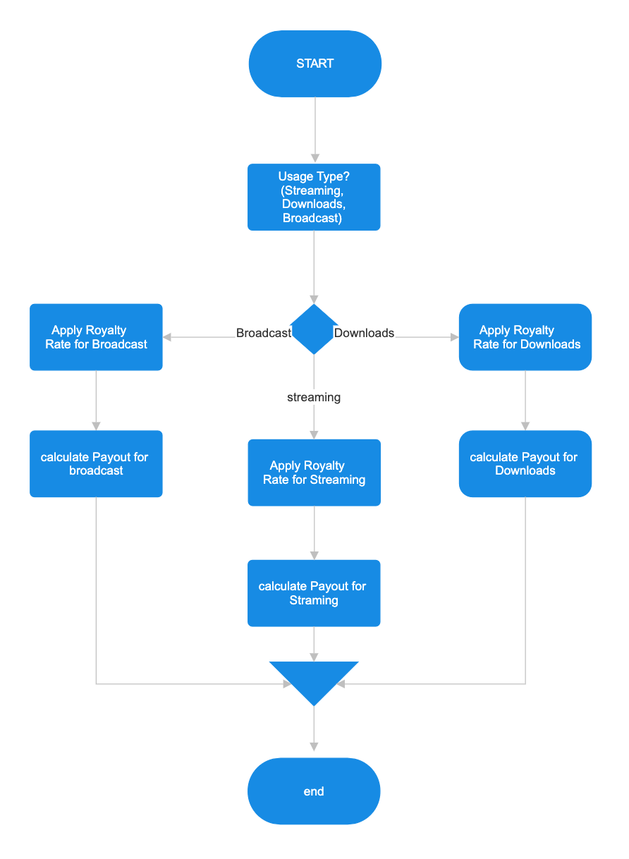

**System architecture bloc diagram** **Royalty calculation flowchart**

SEQUENCE ORDER FOR BMC PROTECTOR PLATFORM

participant User <<ExternalEntity>>

participant MusicPlatform <<ExternalEntity>>

participant RightsRegistry <<SmartContract>>

participant RoyaltyCalculator <<SmartContract>>

participant PaymentDistributor <<SmartContract>>

participant Blockchain <<Blockchain>>

User -> MusicPlatform: Uploads Music

activate MusicPlatform

MusicPlatform -> RightsRegistry: Register Rights

activate RightsRegistry

RightsRegistry -> Blockchain: Record Rights

activate Blockchain

Blockchain --> RightsRegistry: Confirmation

deactivate Blockchain

deactivate RightsRegistry

MusicPlatform --> User: Rights Registered

deactivate MusicPlatform

User -> RoyaltyCalculator: Request Royalty Calculation

activate RoyaltyCalculator

RoyaltyCalculator -> RightsRegistry: Get Rights Info

activate RightsRegistry

RightsRegistry -> Blockchain: Retrieve Rights Data

activate Blockchain

Blockchain --> RightsRegistry: Rights Data

deactivate Blockchain

deactivate RightsRegistry

RoyaltyCalculator -> PaymentDistributor: Request Royalty Calculation

activate PaymentDistributor

PaymentDistributor -> PaymentDistributor: Calculate Royalties

PaymentDistributor --> RoyaltyCalculator: Royalties Calculated

deactivate PaymentDistributor

RoyaltyCalculator --> User: Royalties Calculated

deactivate RoyaltyCalculator

User -> PaymentDistributor: Request Payment

activate PaymentDistributor

PaymentDistributor -> PaymentDistributor: Verify User Identity

PaymentDistributor -> PaymentDistributor: Distribute Payment

PaymentDistributor --> User: Payment Distributed

deactivate PaymentDistributor

Conclusion & Future Work

In conclusion, the research and development of blockchain-based music distribution frameworks, including the innovative BMC Protector, have showcased the transformative potential of leveraging blockchain technology to revolutionize the music industry's copyright protection and distribution landscape. By integrating blockchain's decentralized ledger and smart contract capabilities, these frameworks offer a secure, transparent, and immutable platform for managing music assets, ensuring data integrity, confidentiality, and non-repudiation throughout the music distribution lifecycle.

Looking ahead, several key areas warrant attention to further enhance the efficacy and adoption of blockchain-based music distribution models. Firstly, scalability remains a paramount concern that necessitates innovative solutions to accommodate the increasing volume of music assets and users on blockchain networks. Scalability improvements will be pivotal in supporting the seamless scalability of blockchain technology within the dynamic music industry ecosystem.

Secondly, user education and adoption strategies are pivotal in driving the widespread acceptance and utilization of blockchain-based music distribution platforms among artists, content creators, and music enthusiasts. Enhancing user interfaces, developing intuitive tools, and conducting targeted educational campaigns can facilitate the transition from traditional distribution channels to blockchain-powered systems, fostering greater user engagement and participation.

Furthermore, continuous research and development initiatives are essential to explore emerging technologies, address evolving industry challenges, and enhance the functionality and security of blockchain-based music distribution frameworks. By fostering innovation, fostering collaboration, and embracing technological advancements, the music industry can leverage blockchain technology to streamline processes, empower creators, and create a more equitable and efficient music ecosystem for all stakeholders involved.

In essence, the ongoing advancement and implementation of blockchain-based music distribution frameworks, exemplified by the BMC Protector, hold immense promise in reshaping the music industry's distribution landscape, fostering trust, transparency, and innovation in the digital music ecosystem.